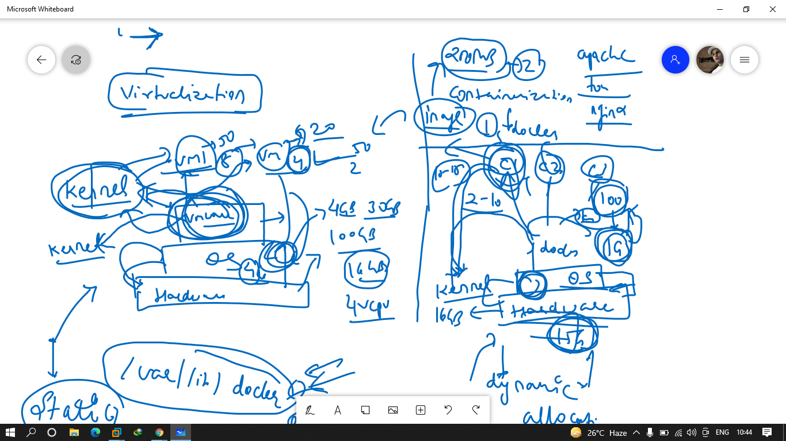

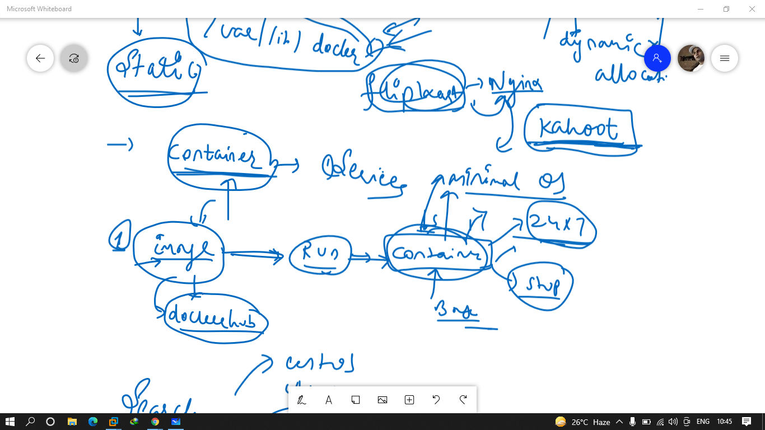

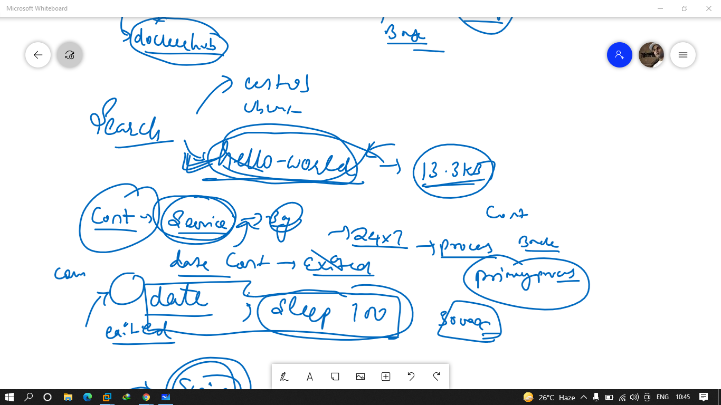

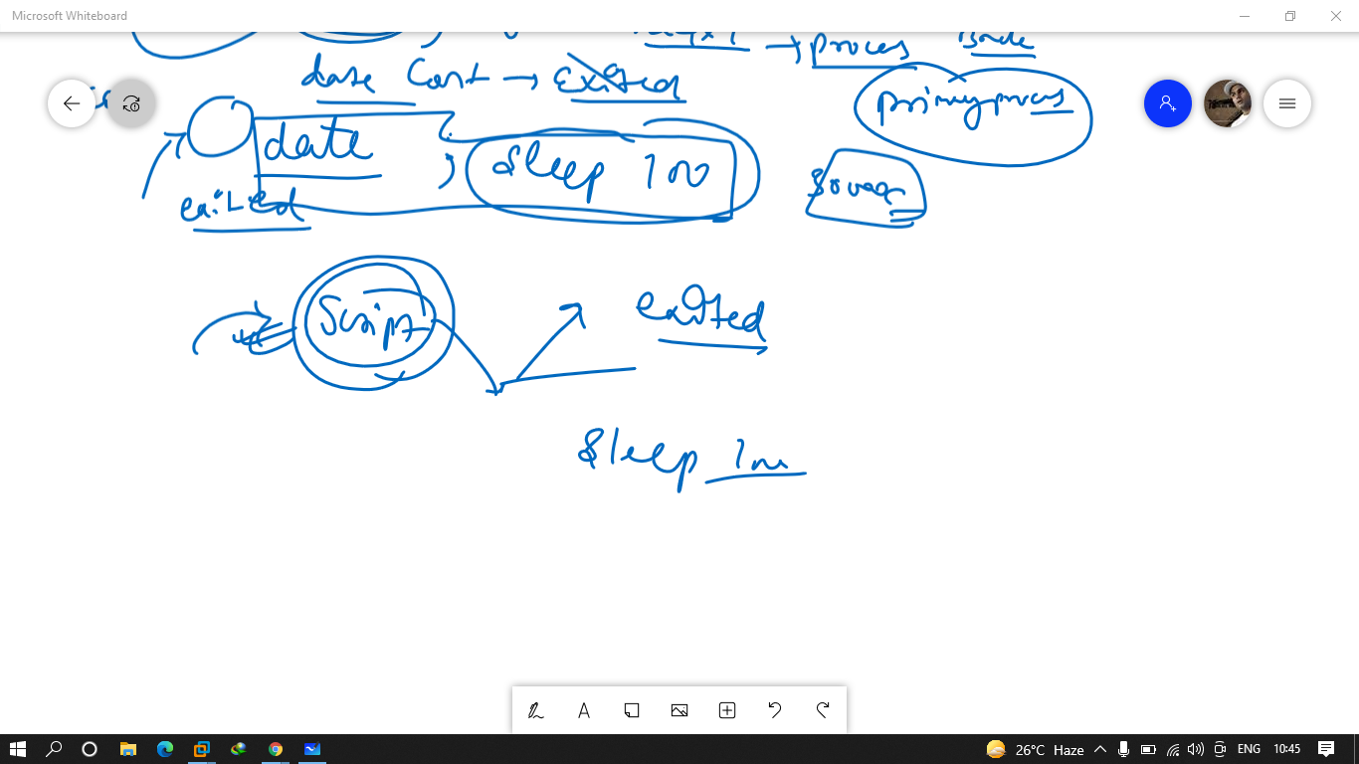

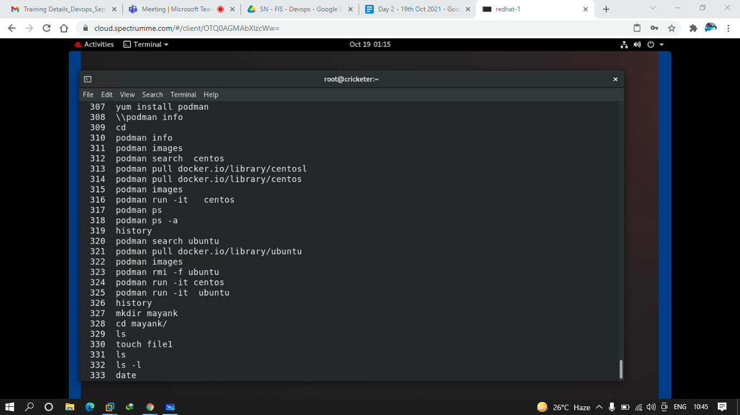

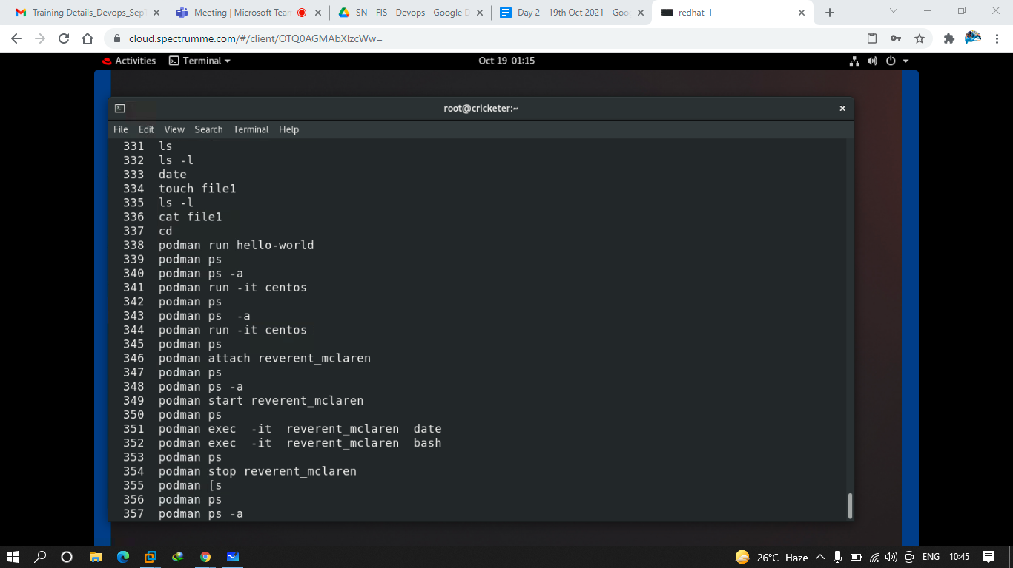

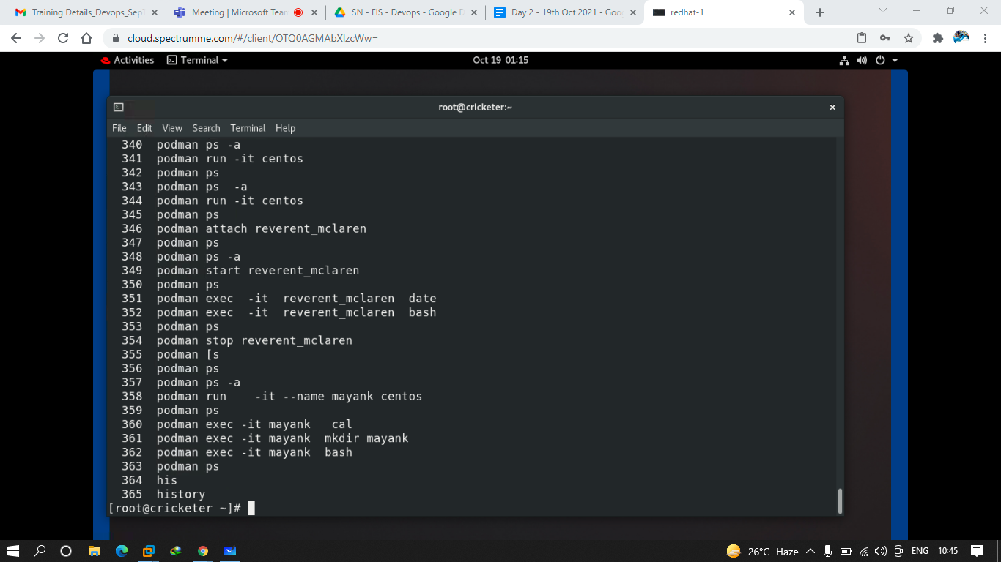

357 history

358 yum install httpd -y

359 systemctl status httpd

360 systemctl start httpd

361 setenforce 0

362 systemctl start httpd

363 history

Q.1 try to pull docker images

1. docker.io/library/centos
2. docker.io/library/ubuntu
3. docker.io/mdhack/myserver
4. docker.io/mdhack/myapache

Q.2 create a container using hello-world image

Q.3 create a container using centos and make it running everytime with the container name test1

Q.4 create a container using ubuntu image with test2 name and make it running 24*7

Q.5 configure apache server in your own lab and try to access the website that you have created in ur firefox browser of the lab,.

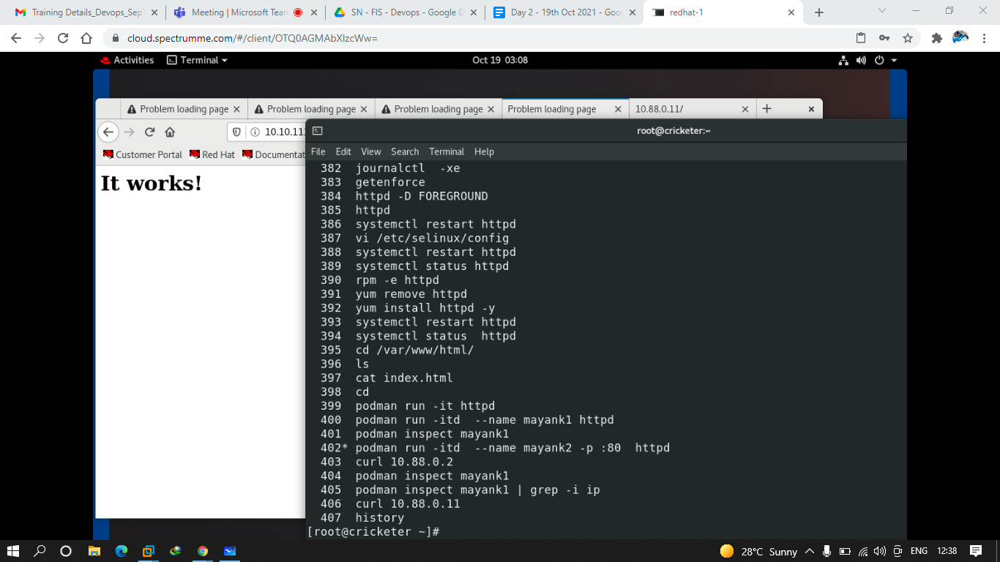

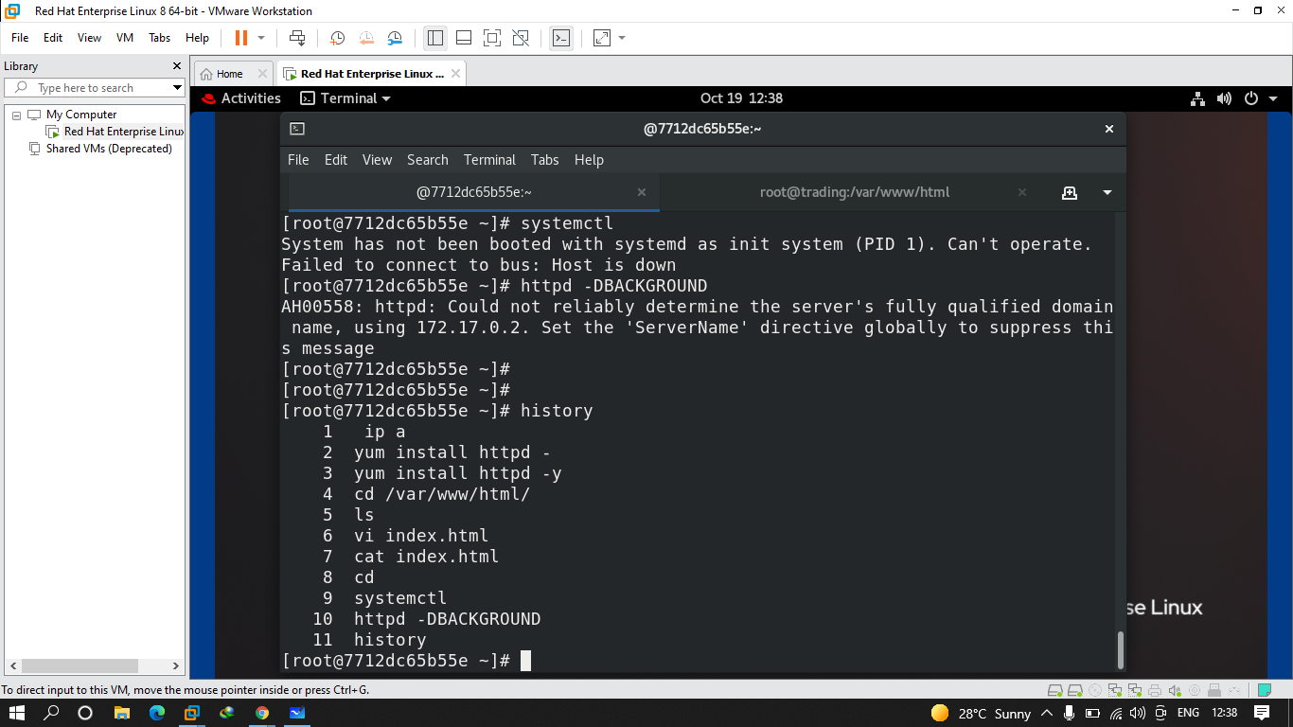

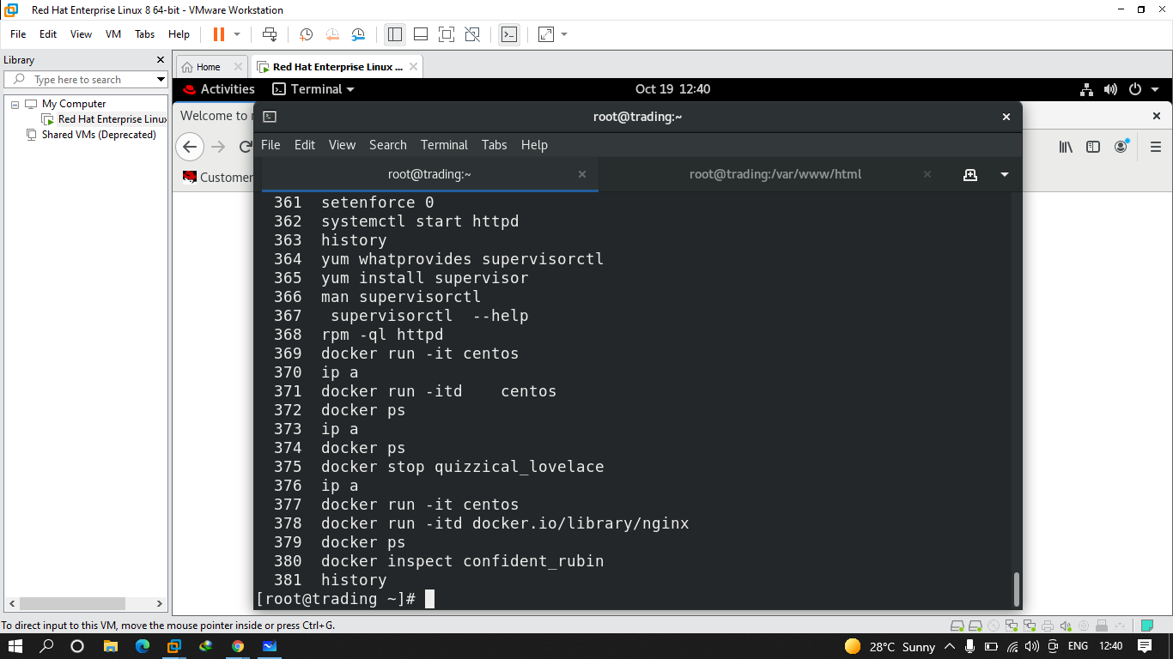

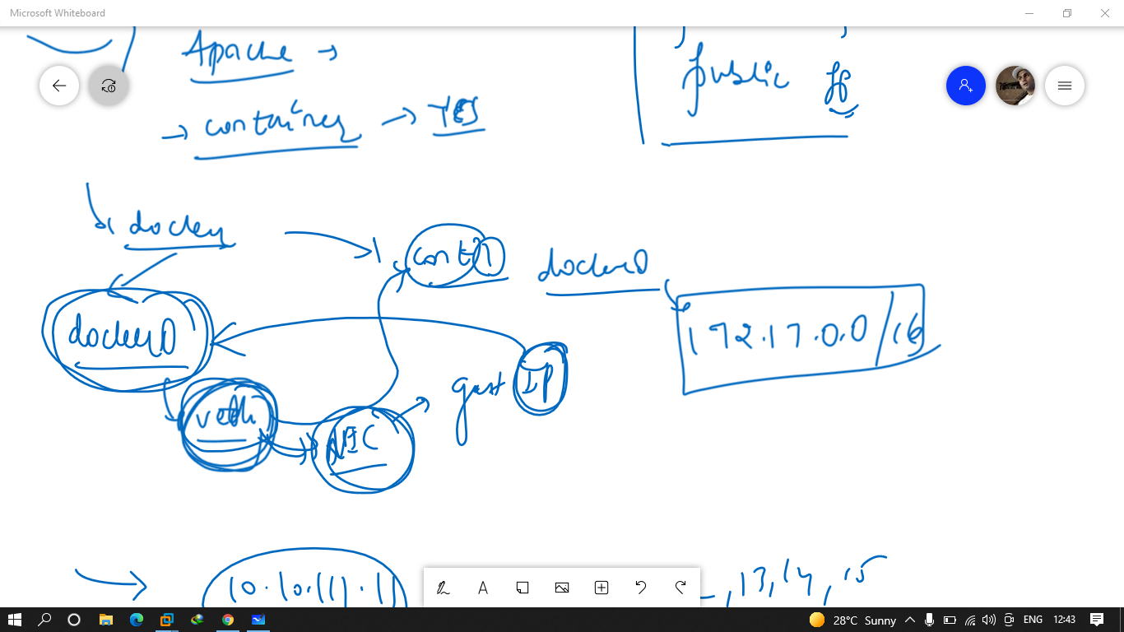

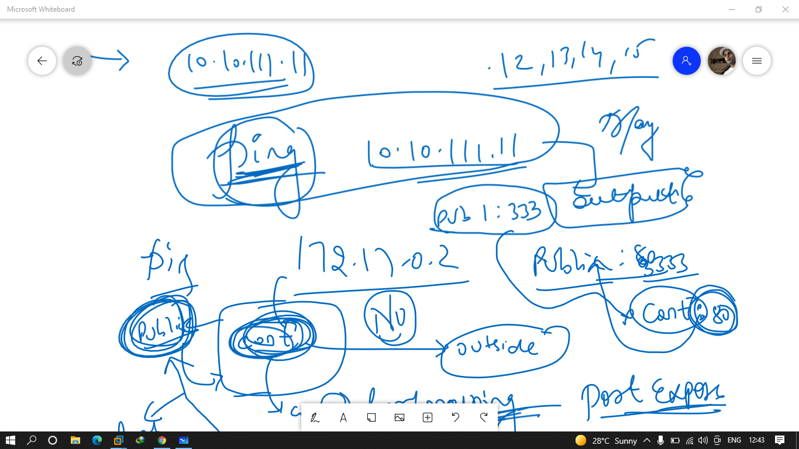

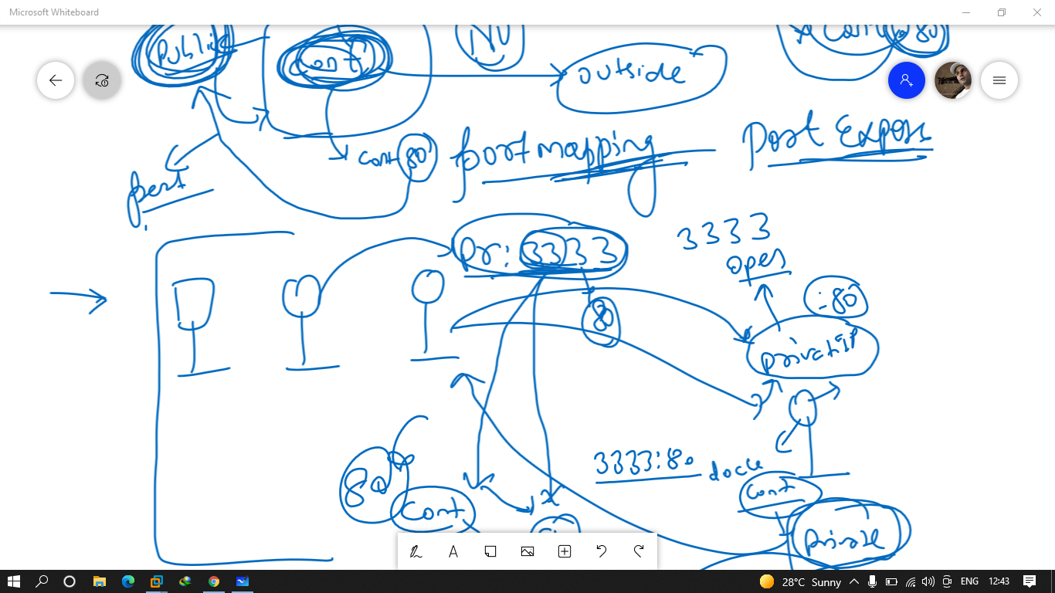

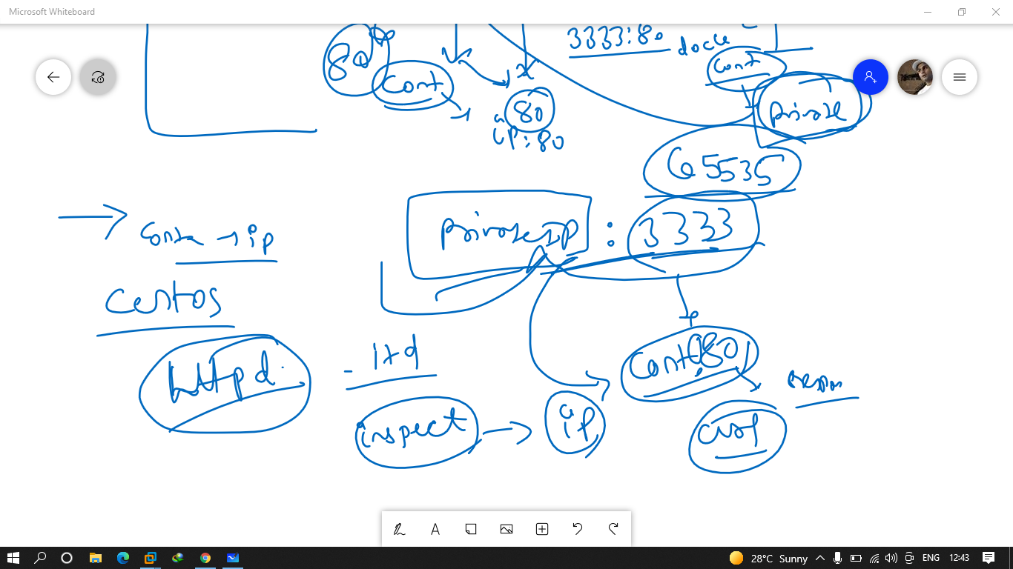

Q.1 create a container using centos and configure apache into it and after that verify your server is working or not by containers ip

Ans.

Podman run -it centos

Yum install httpd -y

Echo content > /var/www/html/index.html

Httpd -DBACKGROUND

Ip a

Get the ip

And in base machine run curl ip

Q.2 create a container using centos and configuring apache into it and expose it to 3322 port no. and verify from browser whether it is working ort not

Podman run -it -p 3322:80 centos

Yum install httpd -y

Echo content > /var/www/html/index.html

Httpd -DBACKGROUND

Ip a

Curl ip

Q.3 create a website using nginx image and the name of the container is mynginx and expose it on 3535 portno.

Podman run -itd –name mynginx -p 3535:80 docker.io/library/nginx

Q.4 create apache server using httpd image and expose it on 3434 port no.

Podman run -itd -p 3434:80 httpd

Q.5 create a server using docker.io/mdhack/myapache image and expose it also on 3233

port no

Podman run -itd -p 3233:80 docker.io/mdhack/myapache

.

Q.6 create a server using docker.io/mdhack/myserver image and expose it also on 3553 port no.

Podman run -itd -p 3553:80 docker.io/mdhack/myserver

docker run -it centos

378 docker run -itd docker.io/library/nginx

379 docker ps

380 docker inspect confident_rubin

381 history

382 docker run -itd -p 3535:80 nginx

383 docker run -it centos

384 docker ps

385 docker commit awesome_wilbur

386 ls

387 docker images

388 docker tag a0a1a4bbb380 test1

389 docker images

390 docker run -it test1 bash

391 docker ps

392 docker export awesome_wilbur -o test2.tar

393 ls

394 docker import test2.tar test2

395 docker images

396 history

ip a

377 docker run -it centos

378 docker run -itd docker.io/library/nginx

379 docker ps

380 docker inspect confident_rubin

381 history

382 docker run -itd -p 3535:80 nginx

383 docker run -it centos

384 docker ps

385 docker commit awesome_wilbur

386 ls

387 docker images

388 docker tag a0a1a4bbb380 test1

389 docker images

390 docker run -it test1 bash

391 docker ps

392 docker export awesome_wilbur -o test2.tar

393 ls

394 docker import test2.tar test2

395 docker images

396 history

397 docker images

398 docker save nginx -o nginx.tar

399 ls

400 docker images

401 docker rmi -f nginx

402 docker images

403 docker rmi -f 87a94228f133

404 docker rm -f 4d7eac7ea688

405 docker rmi -f 87a94228f133

406 docker ps -a

407 docker rm -f romantic_dewdney

408 docker ps -aq

409 docker rm -f $(docker ps -aq)

410 docker ps -a

411 docker images

412 docker rmi -f centos

413 docker images

414 docker load -i nginx.tar

415 docker images

416 docker images -q

417 docker rmi -f $(docker images -q)

418 docker images

419 docker ps -a

docker run -itd -p 3434:80 nginx

422 vi index.html

423 cat index.html

424 docker ps

425 docker cp index.html gifted_jemison:/usr/share/nginx/html/

426 history s

427 history